Sample: sample2_2-SIO2+NB on glass

Fit Results  MSE = 2.499  Thickness # 2 = 30.51 ± 0.194 nm  A = 1.491 ± 0.002088  B = 0.00528 ± 0.001052  Thickness # 1 = 9.24 ± 0.097 nm  n of SiO2 Cauchy @ 632.8 nm = 1.50396  n of Nb205 Cauchy @ 632.8 nm = 2.13608 | Optical Model  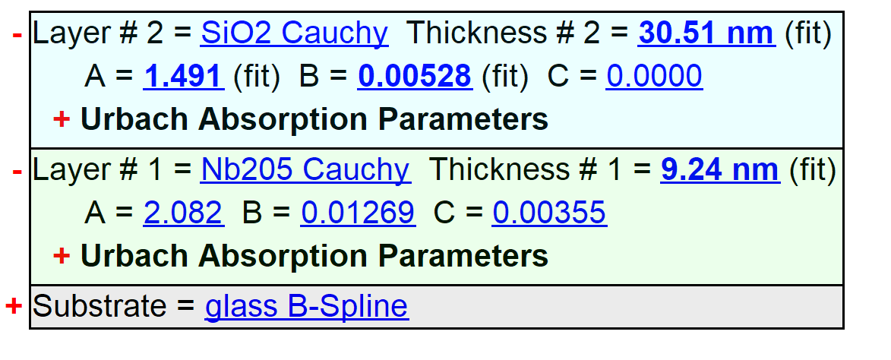

Experimental and Model Generated Data Fits

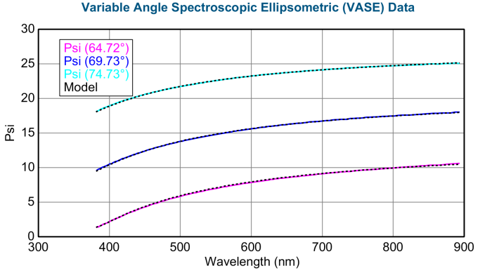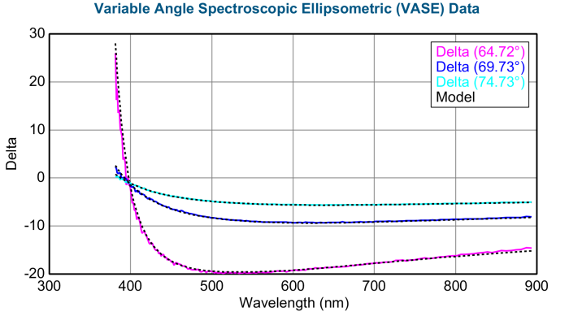
Sample: sample1_2-sio2+ITO on glass

Fit Results  MSE = 1.169  Roughness = 3.59 ± 0.152 nm  Thickness # 2 = 120.09 ± 0.269 nm  Einf = 1.650 ± 3.1231  Amp1 = 1.4290 ± 1.12665  Br1 = 0.341 ± 0.1186  Eo1 = 3.731 ± 0.1965  Eg1 = 1.412 ± 1.0440  Amp2 = 7.699069 ± 12.1022201  Br2 = 3.5536 ± 2.03976  En2 = 8.454 ± 5.0529  Resistivity (Ohm·cm)3 = 4.8057E-06 ± 0.00014932  Scat. Time (fs)3 = 899.484 ± 27909.7154  Thickness # 1 = 40.87 ± 9.602 nm  A = 1.450 ± 0.0241  B = 0.01611 ± 0.004358  n of ITO (GenOsc) @ 632.8 nm = 1.99624  n of SiO2 @ 632.8 nm = 1.49052 | Optical Model  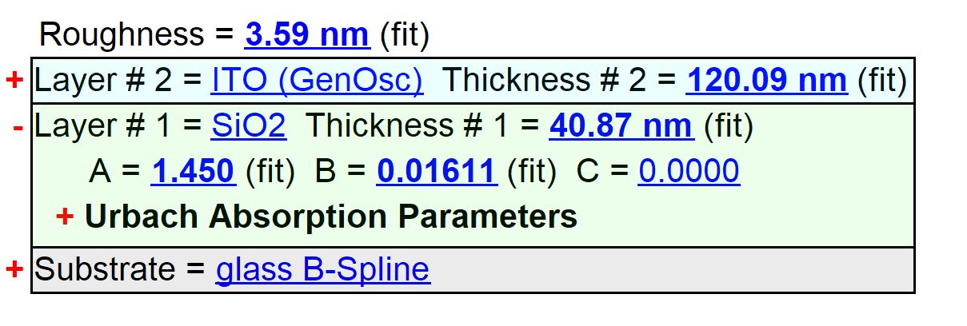

Experimental and Model Generated Data Fits

